Toohard. Speed PG. Q1)True. Gini is faster. Gini isolate largest class from other classes;Entropy more balanced tree.Q7:If Adaboost senmble overfits train. Hyper parameter to weak = Learning RateAdaboost if -1 to +1 increase exponentially. Hac:creating the distance table of examples all pairs of individual examples taks highest time. False:kmeans will always give the same results regardless of the initialization of the centroids.K-means-requirments:Defined distance metric;number of cluster;initial guess as to cluster centroids;Q8

Why the XOR classificiont problem can’t be solved using a single Perceptron because it can only make predictions on linearly separable data.While training the MLPs using back-propagation, the connections weights are updated in which iterative step?GD;Step function doesn’t work well with GD. Q9. Whic reason below is the reason ELU is used instead of leaky ReLU. “ELU saturates large negative value allowing them to be initially inactive”. Momentum Optimization uses grad as accl which may help roll past local optima, but is there any issue?It might roll past the global optimum and make training error diverge. Neural network learning rate schedule=None.Q10.If you apply a 4x4x3 filter to an image of 32x32x3. How many float ops would be needed to compute one node of the next layer. 4x4x3 (use filter not image). Depth of layer 10 use 10. How many parameters does the network need to learn for the pooling layer (0). Why use 1x1 cfilter?Preserves spatial dimensions, reduces depth. Projects depth to lower dimensions. What is the main rason why adding more layers doesn’t necessarily mean better network? It makes the network hard to optimize.

Entropy Information Gain Adaboost HAC Clustering Algorithms SSE of cluster

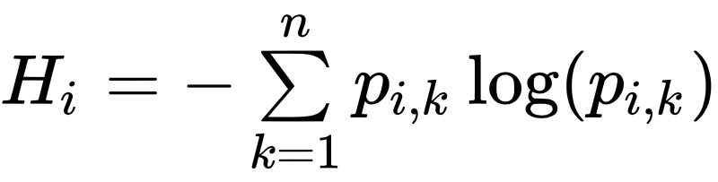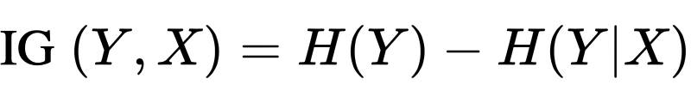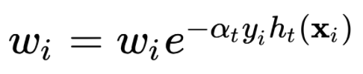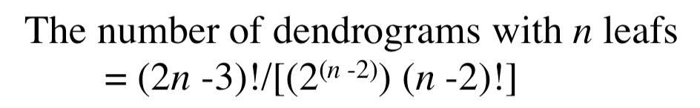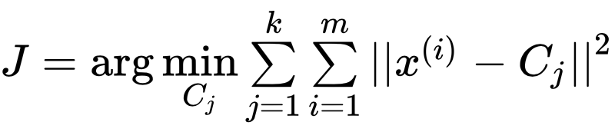



Training Neural Logistic function Q Q Gini

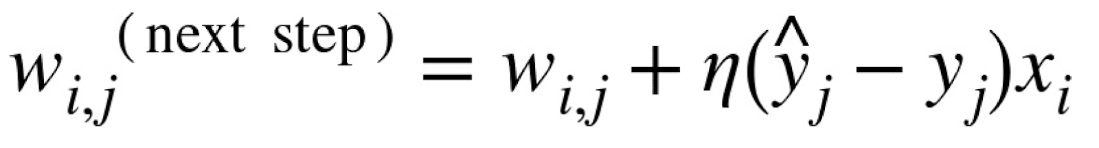  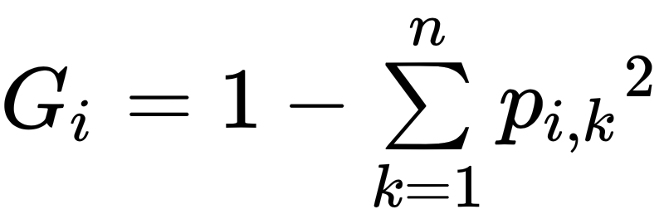

Forward Backwards

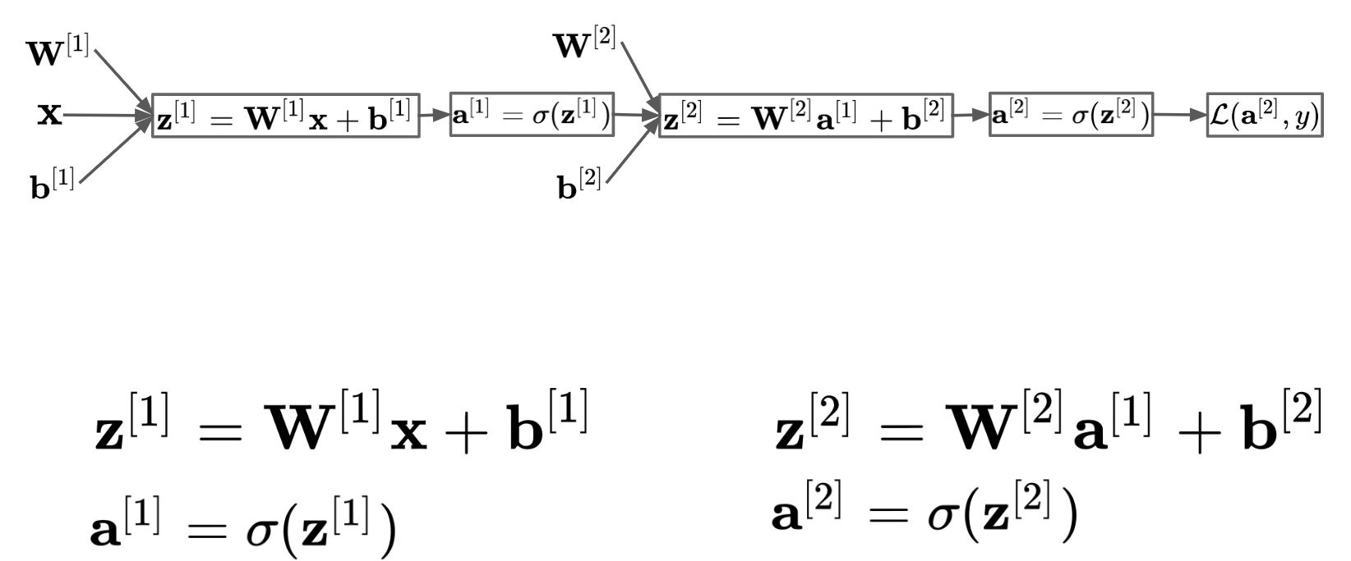

Cart searches pair feature threshold = lowest gini index. Regression = mse. Entropy=balanced&categorical.Gini =numerical&isolate largest class from other classes.Entropy=1. P=

0.5. Infogain=measure reduction in entrop of Y from knowing X. Training comparing all features on ample at each node=O(nmlog(m)). Scalingno.Maxdepth=more depth may me

an overfitting.Appropriate depth = log2(m).Hard=counts.Soft=probabilities(confident classifiers play big).Bagging=decrease var without changing the bias(cuz avg) helps w/

overfitting model. Pasing=w/o replace. Out-of-bag=instance not used cnan use to calc score of algo RF=esemble of DF(bag). Best Feat among random set of feat. HBias&LVar. Featimp=closetoroot.Boosting=combineweak into a strong learner.Train predictors sequentially,correcting its predecessor.Reduce var cuz combine weighted sum of many cla

ssifier.Boost fit tree to entire train. Better each iter=LVar. Bo>Bag>DT. AdaBoost=learningrate.Boost=nohyper.Hac=Bot=find best pair to merge into a new cluster=O(m2n)=Gred

kmean=converge when clusters dont change. Expectation maximization algorithmwhich converges. SSE elbowto find right number of clusters. PCA=hyperplane lies close to data and project data onto it, axis preserves the maximum amount of var.Dimension to add up suff large portion of var. (elbow var vs dim). IncPCA split=minipatch=fit to mem. kPCA

nonlinear projection for dr. Preserves clusters of samples after projections.Will lose data.Manifold=learntrue nature of data. Non-linear reduction.D-dim maniforld is part of n-dim space (d<n). Not lost any info. LLE=manifold not rely on projection. Measure traiing sample linearly relates to neighbor. Look for low-d-representation.. DR speed up. But los info

Perceptron=doesn’t work on non-linear data.ActivationFunc=Step:Zero derivative and not work with GD. Logit function has non-zero derivative for GD. Softmax=classification tasks&usedful in the ouput layer to ouput prob for manually exclusive classes..Regression no need for activation func. ELUvReLU. ELU can take on negative values(avg ouput of the neuron in any given layer is typ close to 0). Helps alleviate the vanishing gradients problem. ELU always non zero deriv. Smooth everywhere unlike ReLU. Tanh=useful if the ouput layer is between -1and1. Logistics useful in the ouput layers when you need to estimate prob. Backpropagation.Foward pass:Feeds a training instance to the network and computes the output of every neuron. Backward Pass:Measure the network error, and computes the error contributions came from each neuron in previous hidden layer. GD: Runs

GD on all connection weights using the measured error.\*Have to replace the act func to logistic function.Fine-tune network hyper=#layer:not always replace layer. Better general

If only changes the hidden the layers. #neurons/layer:funnel technique. Use more layer and more neuron than needed and do early stopping. Early Stopping: interrupt training when its performance on validation set starts dropping. ClassicPerceptron vs Logistic regressor: Perceptron will converge only if the dataset is linearly separable and can’t estimate class probabilities. Logistic regression will converge to a good solution even if the dataset is not linearly separable. If you change the perceptron’s activation function to logistic and if you train it using GD then it becomes equivalent to logistic regression classifier. DNN1:initialization=don’t want the signal to die at nor to explode,how to initialize the weights so that they can do not saturate2)Activiation:Poor choice of activation function can lead to vanishing/exploding gradient(ReLU is fast to compute, but suffer from dying:meaning not outputting anything but 0)can use leaky ReLU to fix this. 3)Normalization:Batch-Norm adds an opearation before activation function 1.Zero-centering 2.Scale and shift the results

To do Batch-norm you need to scale, offset, mean, and std. 4)Regularization:drop out at every training step, every neuron has probability p of being temp dropped out. The hyperparameter p is called the dropout rate.5)Optimization.Momentum:use gradients as accel. If gradient is large speed up the process. AdaGrad:Detects the bot of valley early and corrects its direction to a point more toward global optimum. Achieve this by computing square of the gradients vector.RMSProp fixes ada, (which slow down too fast and may not converge on global optimum) by accumulating only the gradient from most recent interation by using exponential decay if the first step.Adam:momentum+RMSProp. Mom=keeps track of exp decaying average of past gradients. RMSProp=keep track of an exponentially decaying average of past square gradients.Vanishing gradient:gradients get smaller that they leave the connection weights virtually unchanged. Opposite=exploding. Convolution Layer neurons in first cl are not connected to every pixel in the input image, but only to pixels in their receptive fields. Neurons in the second cl is connected only to neurons located within a small rectangle in the first layer. Concentrate on low-level features in the first hidden layer, then assemble them into higher-level features. 0padding=add zeros around the inputs. Stride=connect large input layer to much smaller layer by spacing out fields. Pooling:Subsample the input image in order to reduce the computational load, mem and number of parameter;no weights;AlexNet:stack convoluation layers directly on top of each other.Google:Inception moduel. Good local network topology. ResNet.Skip connection(copy solution from shallow model and set additional layers to identity mappingCNNvDNN

C has fewer parameter than dnn=make faster to train, reduce overfitting and requires less data.c learns a particular feature, it can detect that feature anywhere on the image while d learns a feature in one location and can only detect in only that particular location. c genealizes better for image. D no knowledge of how pixels are organized.Model=learn the model then use and update it often.Value-Learn the state value, act by taking best action, and explore if necc. Policy-Based:learn the stochastic policy function that maps state to action, act by sampling that policty. Q-learn:Stat-action value function:returnwhen startin in s, performing a. No info about env at the begin. Try all actions to find opt.Experience Replay:current Q-network parameters determine next training ex.pg:r(t)high=push up the prob of the actions seen.r(t) is low, push down the prob of actions seen. PGvsQ.maybe

fffffff